

*QUALEATY*

*Healthy , qualitative, cheap*

**Qualeaty – mean to be of the buisness**

Out of the numerous societal issues the young generation is confronted with, we believe there is one that needs to be addressed in a more urgent and serious way: the worsening of eating habits for the student population.

[For many students](https://www.lemonde.fr/campus/article/2019/10/10/pizzas-sandwichs-et-tacos-a-la-fac-ou-en-prepa-comment-j-ai-commence-a-manger-n-importe-quoi_6014892_4401467.html), college and university years mean the time when they leave their homes and start to manage life on their own. Busy schedules organized around classes, group meetings, homework, part-time jobs and day-to-day errands can soon lead to neglecting one’s health, as doing sports or cooking a healthy meal will not be on the top of their priorities. Instead, during school time, they will tend to choose more and more snacks or fast food that are accessible in their area.

A [survey](https://harris-interactive.fr/opinion_polls/les-etudiants-et-lalimentation/) conducted by [Harris Interactive France](https://harris-interactive.fr/) in June 2017 (Institute for Marketing Studies and Opinion Polls) shows that most of the students interviewed (sample of 600 people representative of post-bac students in France) would like to include more vegetables (71%) and fruits (66%) in their daily meals.

57% of the students confirm that their diet is affected negatively during exam and revisions weeks and 78% of them wish to have a more balanced diet in general.

Analyzing the Parisian student population through a survey conducted at a micro level in our university helped us understand that meal options for lunch are indeed limited. Stressful schedules, along with the lack of money and time resources make students orient their choices towards sandwiches and pastry very often, which can affect physical condition on a long-term. Students need more variety in their options and more nutritious and healthy lunch menus. And all that at a reasonable price, because we know that [financial aspects](https://www.francetvinfo.fr/societe/education/j-ai-un-euro-par-jour-pour-manger-trois-etudiants-temoignent-de-leur-grande-precarite_3699885.html) can be an issue for our target population.

As we are concerned about our generation’s wellbeing a possible solution would be to create a lunch option that brings cheap, accessible and healthy for students around the area they are studying in. Our challenge would then be the following: ***How to offer a complete and qualitative meal for students, knowing that their lack of time and budget determines their choices***

**Description of our project**

The concept

We wanted to create a business who target students that could provide them healthy and diversify meals prepared with organic food and that will be abordable for a student budget. It has to be a “fast food” in order to suit the rhythm of their daily life as well as flexible to their preferences. Also, the main aspect we wanted to focus in is the interaction with our customers. Basically we want the client to be part of the business. In order to create that we though about an interactive application in which the consumers can order before taking up their meals but also vote for the menus they want to have every week.The application will be the way to create a “Qualeaty” social network community.

We believe in a great transition and in concrete actions to save our planet. We want to be a brand of the future, equitable, responsable and connected to people. Qualeaty will be part of the change of the consuming behaviours.

Our target

Our store will take place the 7th district close to Sciences Po. We choose to target specially students form the district 7th ( Assas, La sorbonne, Sciences Po) for two reasons. First, as we are ourself sciences Po students it was easier to conduct a survey among them about their preferences and behaviours. Secondly, it is a population of students that is receptive to the message we provide and has more budget to eat daily in our store.

How it works ?

We decided to provide only lunches for our customers. We have a chef who have a list of 25 diversified and original meals. Every friday we propose to the customers to vote for one meal between the five proposed. The first 3 meals for which the customers have voted will be the one proposed every day from monday to saturday during one week. We repeat the same process every friday with five different meals. This method allows us to proposed diversified and suitable lunches for everyone. 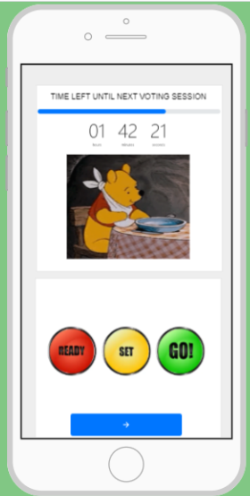

The offer

We wanted to respond to the demand of the students.The product will be fresher as possible and quite everything will be organic and produced in France. We are vegetarian and vegan friendly. We believe that we should better provide vegetables proteins than meat. Therefore in the quotas of the five meals their will always be one entirely vegan and one with meat (halal) .. All the others will be vegetarians constituted of vegetable proteins such as beans, lentils, cumins spice, spinach.

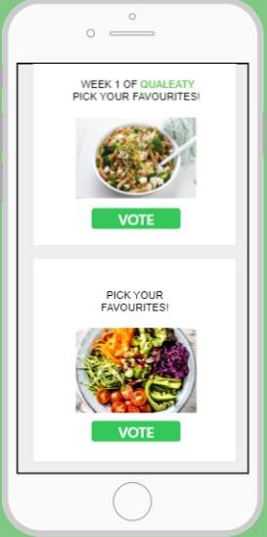

The price will be about 6 euros and will include one meal (out of the three of the week). We will also have a formula with a dessert and a drink around 8,50.

It will be possible to order and pay in the application. Customer will have a QR code and will just have to come to the store to take off the lunch. This way it is simple et faster. They don’t waste time doing a queue and waiting for their meal to be prepared.

**Business plan**

We conducted a survey among Sciences Po students in order to orientate ourselves whether our predictions about young adults’ eating habits are correct and will they potentially be interested in something like our project. We received 154 answers on which we base our analysis.

Through our answers we saw that indeed eating healthy food seems like an important preference for most of the students (**87%).** This shows us that even if they may not necessarily have healthy habits, they appreciate quality food. However, having healthy food is not the only factor. Prices play big role in the decision making process. **44%** consider the healthy factor the most important and the rest puts emphasis on prices as well. When talking specifically about lunch (the time we will be selling), although we saw that actually the majority of the students think that there is already enough diversity of lunch options around Sciences Po, still **34%** are rather unsatisfied, a number that is too high to be ignored. The places that attract the most students for buying lunch are the Crous cafeteria in the school **(43%)** and after it the bakeries nearly **(28%)**. This can be explained by the convenience of these places and their accessibility, offering something relatively cheap. Moreover, we noticed that half of the people studies consider stressful periods in school as a major detriment in their eating habits. Consequently, this makes us believe that switching from cooking food home and regularly buying outside, is pretty volatile and could be correlated to the academic pressure.

As a conclusion, what makes us believe there could be potential market for our business idea and that we may succeed easily if we target well our segment- the students, is the fact that **82%** answer favorably on the idea of eating homemade food and being included in the decision making process. Moreover the price range they are willing to pay is between **5 and 7 €** if they perceive the food as healthy and tasty. That confirms our beliefs that the quality of the food and the presentation of it are cornerstones we will need to focus our attention. The only tricky part is how to become a relevant player in the minds of students when choosing from where to buy their lunch and how to attract them since our pricing is a bit higher than the other alternatives.

**Answers of the survey**

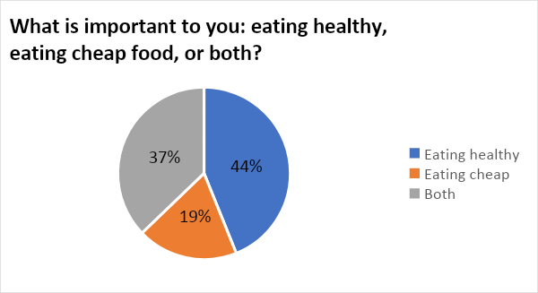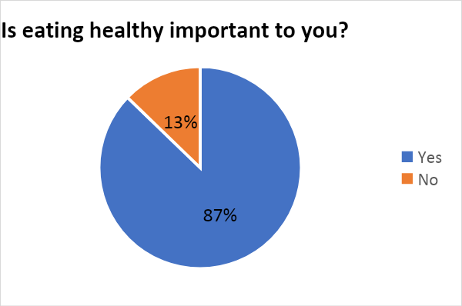

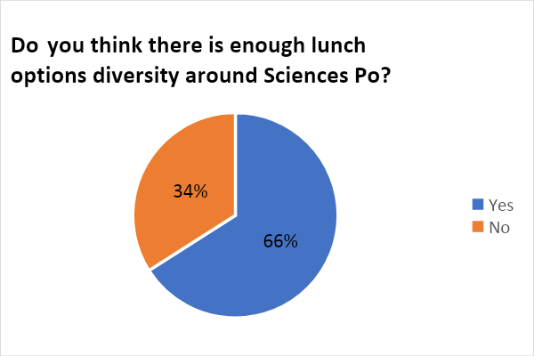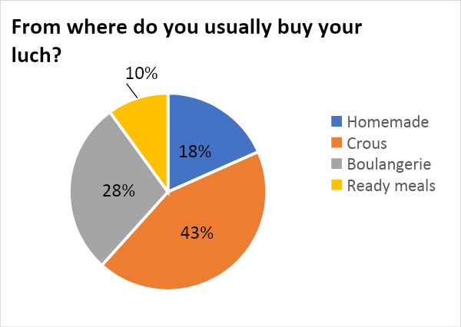

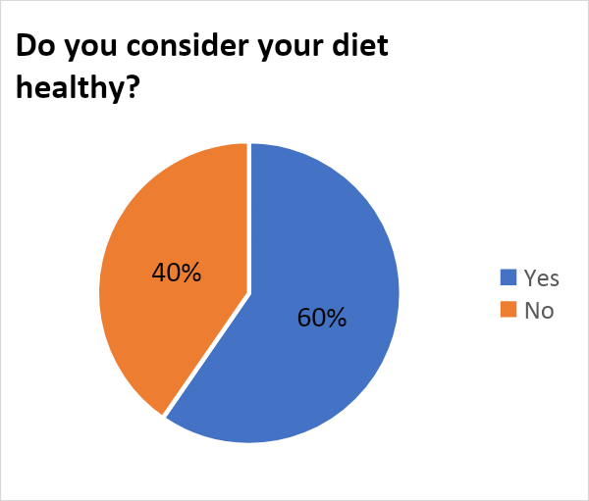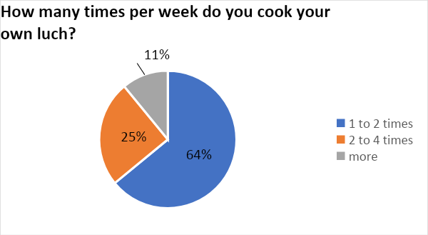

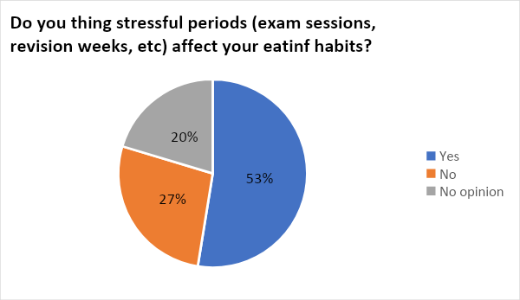

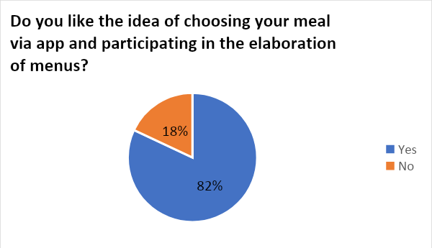

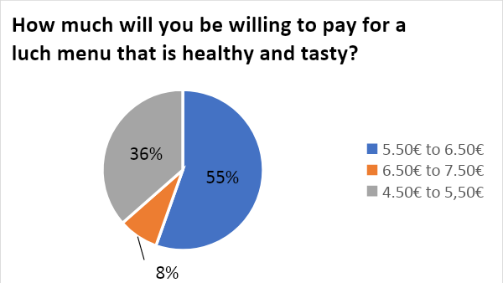

Based on this results and our vision of the vision, we created a business plan.

